Haunt My House Manual

For 4 – 6 players

This manual is your holy grail for ghost.

It tells you everything you need to know about ghosts and how to banish them.

Keep this with you at all times, it may save your life!

From the Hoppi Studio Team.

Contents

Introduction 4

Setup 4

How To Play 4

Blockout 4

Ghosts 5

Introduction 5

Puzzle Guide 5

Candle puzzle 5

Lever puzzle 6

Symbol puzzle 7

# Introduction

## Setup

One player is given the VR headset to wear.

Two players each take one of the VR controllers.

The remaining players will act as information handlers to help the VR players complete actions and win the game.

## How To Play

To win the game, you will need to work with the person with the headset and the people holding the controllers to solve all the puzzles before the time runs out and ghosts kill you!

There are a total of three puzzles to solve to banish all ghosts – a symbol puzzle, a lever puzzle and a candle puzzle.

You can see your life and the progress of each puzzle on the game screen.

## Blockout

Before playing the game, you will need to blockout world objects inside the game world. Use the **Trigger** **button** on the **right** **controller** on three corners of an object to create a virtual object.

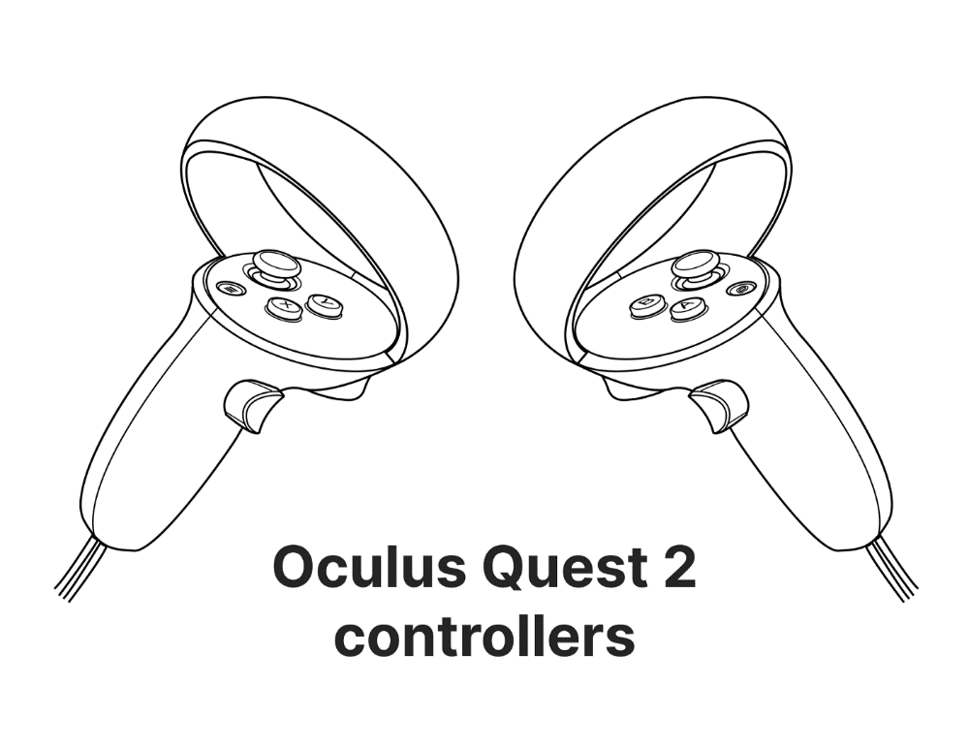

Menu selection

Object Blockout

Once you have finished blocking out the objects in the room, press the continue button to begin the game.

# Ghosts

## Introduction

Each ghost you encounter will be different and, as such, will require a different puzzle to be solved to banish it.

# Puzzle Guide

## Candle puzzle

To solve this puzzle, you must:

1. Light up the matchstick using the matchbox. To light the matchstick, use the Trigger button to grab objects and button A to light it up (as seen on the picture).

Light matchstick



Grab candles/matchbox

1. Approach a candle with the matchstick and mix two colours of a choice to receive a third colour (see colour combination below).

Colours available

Colour combinations:

X =

X =

X =

1. Grab a candle from the table, light it up and place it on one the corresponding pedestals with one of the colour combinations shown below:

1. 2. 3. 4. 5. 6.

1. 2. 3. 4. 5. 6.

1. 2. 3. 4. 5. 6.

## Lever puzzle

The second puzzle has five levers which need to be set in their correct state to pass through the puzzle. The solutions are the following:

1.

2.

3.

## Symbol puzzle

The last puzzle is a symbol puzzle where talismans need to be put on pedestals to match the correct order. The solutions are below:

1. 2. 3. 4. 5. 6.

1. 2. 3. 4. 5. 6.

1. 2. 3. 4. 5. 6.